Calculate R Expression

Description
The functor 'Calculate R Expression' allows Dinamica EGO to call R externally and process the script outputs as if they were part of Dinamica itself.

Inputs
Name | Type | Description
Expression | String Type | The expression that will run on R.
Treat Warning As Errors | Boolean Value Type | Warnings on R script will be considered errors.

Optional Inputs
None.

Output
Name | Type | Description
result | Struct Type | A struct containing the output values generated by the expression.

Group
Integration

Notes
There are two ways to setup the 'Calculate R Expression' functor:

Dinamica EGO Enhancement Plugin
Simply download and install the Dinamica EGO Enhancement Plugin. It contains everything you need to run R scripts inside Dinamica EGO.

Local R Installation
Additionally, users can specify and use their own local R installation for execution. The pre-requisites are:
* R needs to be at least at the 3.3.1 version.
* Rscript.exe must be valid and located at the 'installation folder\\bin' sub-folder.
* Dinamica package for R must be installed and at the latest version.
To specify your custom R installation, go to Tools -> Options -> Integration tab and select 'Use alternative R installation for Calculate R Expression':
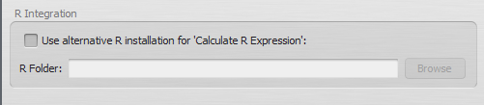

Usage
The functor is available under the 'Integration' tab at the library.

R Script Inputs
To pass input parameters from Dinamica EGO to R, hooks must be placed to collect data. You can use the 'Create a hook' button on the selected functor bar or drag the hooks individually. The valid hook types are:
* Number Table
* Number Value
* Number String
To access the passed inputs on your R script, follow Dinamica EGO naming conventions and use t[0-99], v[0-99], s[0-99] for each type respectively. For example:
# Will store the 5th key from the passed LookupTable in the variable 'testing'
testing <- t1$Keys[ 5 ];
# Store the second passed String.
secondString <- s2;
# Store the 10th passed Value.
tempNumber <- v10;

R Script Outputs
To output data back to Dinamica EGO, the user must call a set of functions designed for this functionality:
Function name | Output Data Type | Usage Example
outputDouble() | Real | outputDouble( “myDouble”, 3.14 )
outputNumberVector() | Tuple | outputNumberVector( “myTuple”, c(1:10) )
outputString() | String | outputString( “myString”, “This is a string” )
outputLookupTable() | LookupTable | outputLookupTable( “myLUT”, c(1:10), c(1:10) * 10 )
outputTable() | Table | outputTable( “myTable”, anyTable, 4 )
In the examples above, data was constructed inside the calling functions. You can also specify variables as parameters.
 | All output functions require an identifier as the first parameter, that's the name Dinamica uses for retrieving the correct data.
Keep in mind:
* You can pass any kind of numeric value on the outputDouble function.
* Collections of numbers are valid Number Vector's.
* A LookupTable requires 2 number vectors, one for the Keys and another for the Values. Both vectors must have the same number of elements.

Tables / Lookup Tables
Tables or Lookup Tables can be transferred to R using the Number Table functor. When dealing with each of these types extra caution must be taken:

Lookup Tables
Lookup Tables are transferred to R as a List with two columns, “Keys” and “Values”.
Each column can be individually accessed by using the $ operator, for example:
* t1$Keys[ 1 ] will access the first key of the LookupTable t1.
* t2$Values[ 2 ] will access the second value of the LookupTable t2

Tables
Tables are transferred to R as a DataFrame type variable. Each column can be individually accessed by using the $ operator, just like LookupTables. Please check this page for more information on how to deal with Tables. The rules for them in Calculate R Expression are the same as sending and receiving through External Communication.

Example Scripts
* Multiply each value of the passed LookupTable by itself
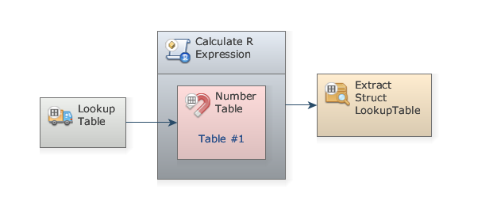
Expression:
for ( i in 1:length( t1$Values ) ) {
tempValue <- t1$Values[ i ];
t1$Values[ i ] = tempValue * tempValue;
}
outputLookupTable( "poweredTable", t1$Keys, t1$Values );
* Extract the mean of passed LookupTable values
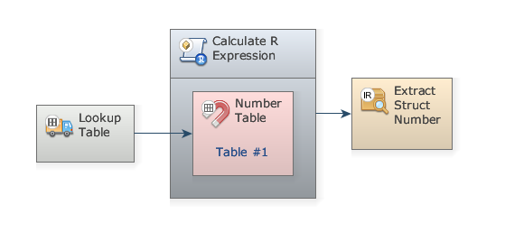
Expression:
tableMean <- mean( t1$Values );
print( paste( "Mean is", tableMean ) );
outputDouble( "mean", tableMean );
Noticed the print() statement? Dinamica EGO's Message Log will show output messages from the R script.
* Plot passed LookupTable to an image on the path specified by passed String
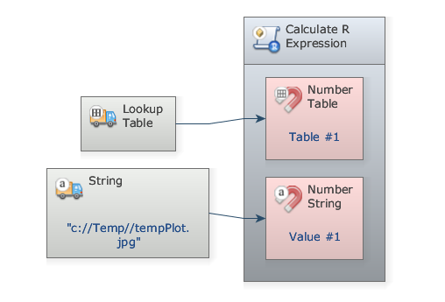
Expression:
outputFile <- s1;
print( paste( "Plotting to", outputFile ) );
jpeg( outputFile, quality=100 );
plot( t1 );
dev.off();

Internal Name
CalculateRExpression

