Processes
The model is fed back to the end of each step and follows this general sequence of the processes:
Births
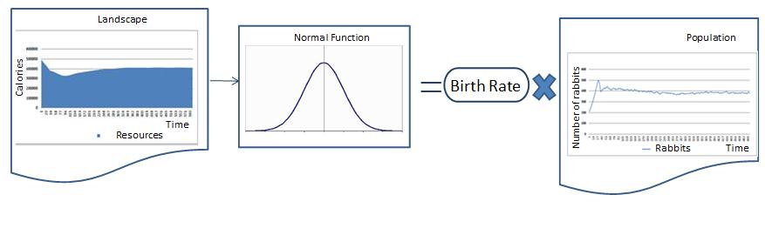
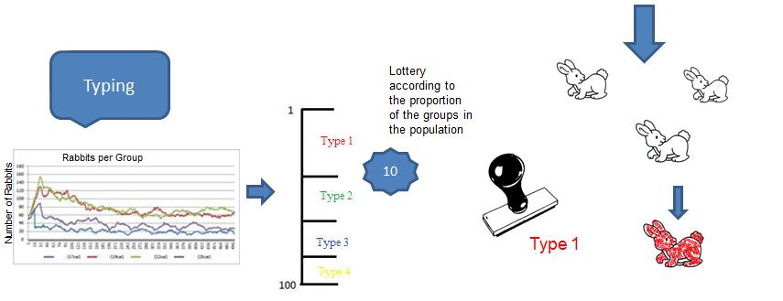
The number of births in a time step is defined by a rate determined by a function whose average is influenced by the amount of resources in the landscape.This rate multiplied by the number of rabbits in the current time step define the number of births. After the birth agents are distributed in groups (types) according to the proportion of types in the population.
Movement
The agent analyzes the amount of resources in the cells around it considering its capacity of vision and the cells not occupied by other agents. It looks for the cell with the greater amount of resources. When it moves to this cell the amount of resources given by the parameter attribute “Resources spent to move” is subtracted from its stock of calories.
Feed
After the movement the agent extracts the amount of resources until the limit of its absorptive capacity considering the attribute parameter “Maximum absorption of resources”. This value is subtracted from the corresponding cell in the map of resources and is added to the agent’s stock of calories. Landscape recovery Recovery happens every time step considering the current amount of resources in the cell and the maximum capacity of resources through a logistic function.
Landscape recovery
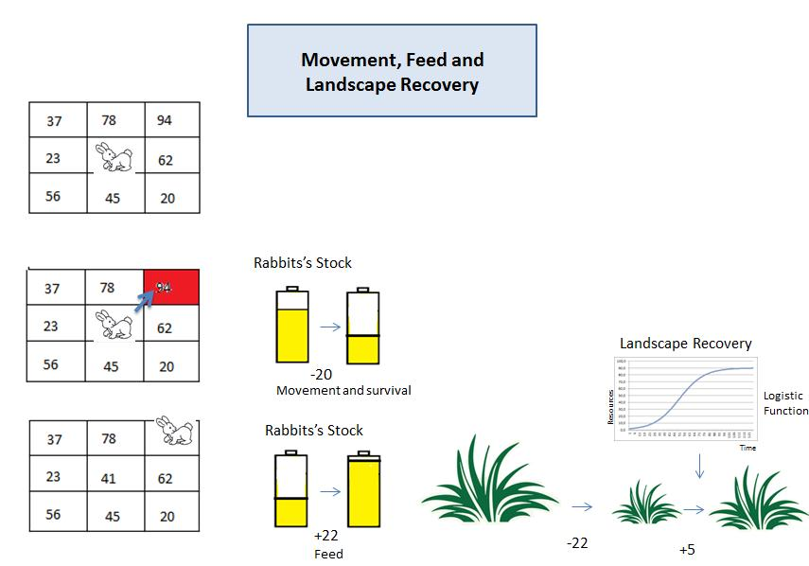
Recovery happens every time step considering the current amount of resources in the cell and the maximum capacity of resources through a logistic function.
Death
There are two causes of death for agents:
-Starvation: lack of enough energy to stay alive. It happens when its stock reaches to zero calories.
-Age: the number of deaths in a time step is defined by a value that represents the average of a normal function that will determine the maximum age for an agent to live at each time step. If its current age is greater than this value the agent dies, if it’s not it remains alive.
Overview
The population of rabbits, the landscape and the amount of energy of each individual can be seen as stocks of agents, resources and calories respectively. The stock of agents increases with births and decreases with deaths, the landscape resource stock increases with landscape recovery and decreases with the total consumption by the the agents population, and the stock of calories of an agent increases with consumption and decreases with metabolism and movement, both individual. The stock of landscape resources influences in the birth process as well as the stock of the rabbit population. The number of agents also directly influences in the total consumption of the resources and the decrease of the stock of agents population depends on the individual's age and calories.


