Scenarios
In this model different scenarios were represented by different landscape maps. The amount and distribution of the resources were modified to analyze all model results with
Landscape: 100×100 image representing the spatial distribution of resources.
The landscape map is an input designed according to the study context. To this study we mostly used three maps representing three different scenarios
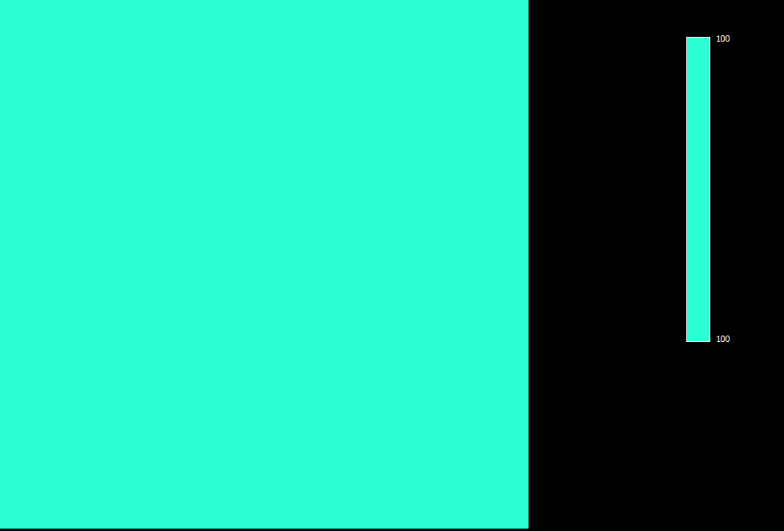
This scenario (Hom 100) represents a landscape where the resources are distributed equally across the space, like in a pasture, for example. In this way, every cell has the same value in this map: 100 - Summing 1000000 units of resources, average cell value: 100 -
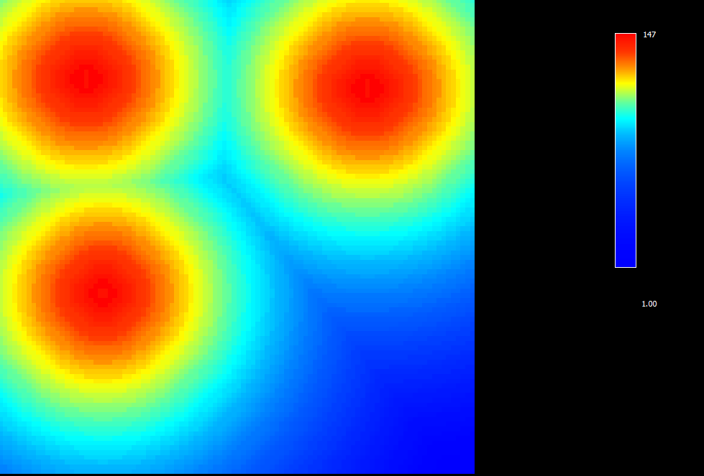
This scenario (Het 100) represents a landscape where the resources are distributed differently across the space. There are three points with the highest concentrations of resources and this amount decreses with the distance to this points. In this way the cells have different values in this map: 0 to 147 - Summing 1000000 units of resources, average cell value: 100
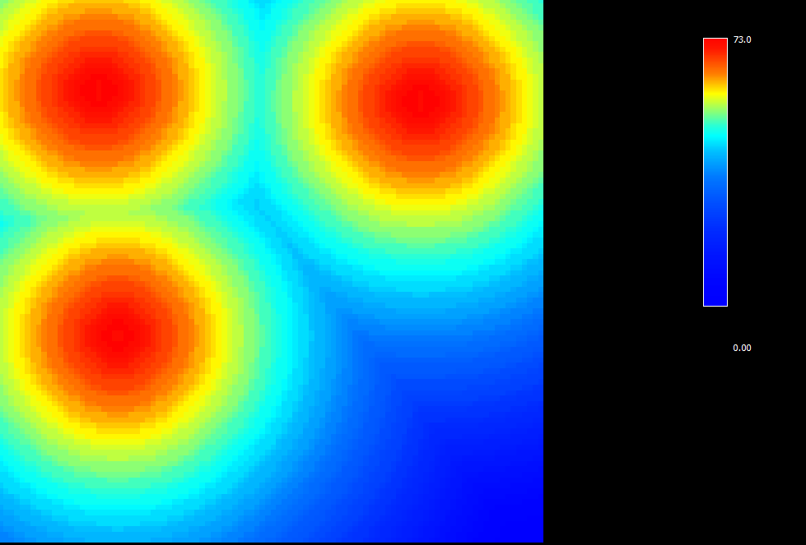
This scenario (Het 50) represents a landscape where the resources are distributed differently across the space. There are three points with the highest concentrations of resources and this amount decreses with the distance to this points. In this way the cells have different values in this map: 0 to 73 - Summing 500000 units of resources, average cell value: 50.

