Launch Dinamica EGO GNU/Linux

Setup
Extract the downloaded file to a folder of your choice. The directory should contain:
Dinamica.AppImage
Examples and Submodels.zip
README.html

Examples
The file 'Examples and Submodels.zip' can also be extracted to a folder of your choice.
This new folder will contain the sample Models, Data and Submodels distributed with Dinamica EGO.

File Manager
Right click on Dinamica.AppImage and choose Properties. There should be a Tab named 'Permissions' where you can find the option 'Allow executing file as program'.
Make sure this option is checked. This window can look a bit different depending on your distribution settings.
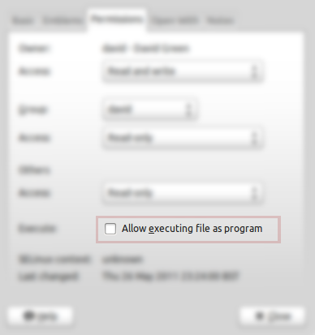
Double click on Dinamica.AppImage to launch Dinamica EGO.

Terminal
Open your favorite terminal application and navigate to the folder corresponding to the extracted folder.
Suppose you extracted your files to /home/csr/DinamicaEGO:
cd /home/csr/DinamicaEGO
chmod +x Dinamica.AppImage
You can then execute the application by typing:
./Dinamica.AppImage

